BUSINESS ANALYST CASE STUDY
Cutting Returns Losses Through Real-Time SKU Visibility
How a requirements-led redesign of the returns workflow turns a week-long blind spot into a same-day signal
49.9%  of all returns come from just 3 SKUs | 3.5x  longer to process an online return vs in-store | £22.5k  in refund value tied to those 3 SKUs alone

1. The Business Problem
Returns are processed, but nobody is watching for patterns. Store staff log a return, issue a refund, and move on — there is no mechanism that surfaces when a specific product is generating a disproportionate share of returns until a manual weekly batch review, by which point the pattern has often been running for weeks. Online returns compound the problem: they take on average 3.5x longer to process than in-store returns, with no SLA in place to catch the delay.
The result is a blind spot that costs the business twice — once in the refund value itself, and again in the lost opportunity to fix a root cause (a mislabelled shade, a faulty batch, an inaccurate product description) before it generates the next 50 returns.
2. Recommendation & Expected Outcome
Move SKU-level return tracking from a weekly manual batch review to a real-time dashboard with automated threshold alerts, and introduce a separate processing lane for online returns with a defined SLA.
- Cuts the detection lag on high-return SKUs from ~7 days to same-day, giving the buying/merchandising team a 6-day head start on root-cause fixes.
- Targets the 3 SKUs responsible for 49.9% of return volume and £22,520.69 in refund value as the first candidates for investigation.
- Sets a 3-day SLA target for online return processing, closing most of the current 4.4-day gap versus in-store.
Full analysis, source data, and live formulas are in the accompanying workbook (Returns Analysis.xlsx).
3. The Data
Analysis is based on 950 return records across a 12-month period (FY 2025/26), covering SKU, return reason, processing channel, region, and refund value. Full methodology and assumptions are documented in the workbook's Notes tab.
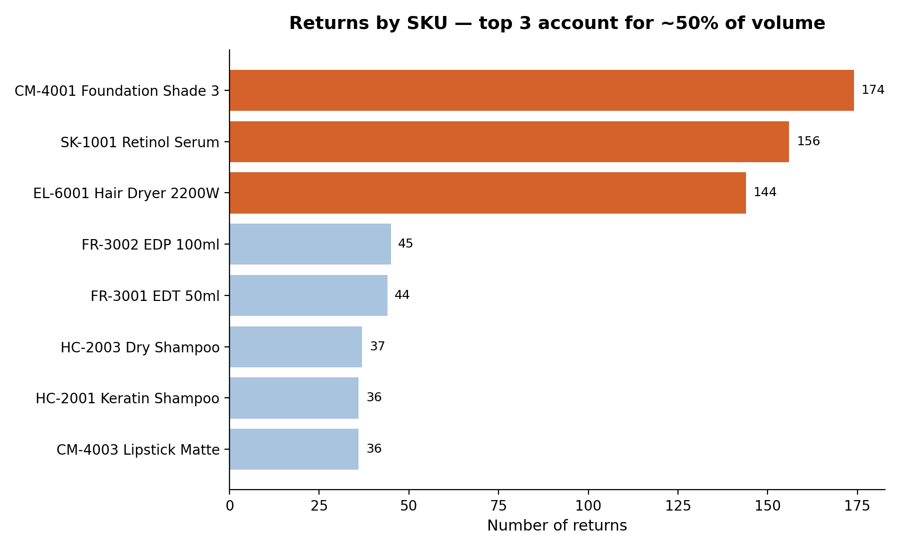
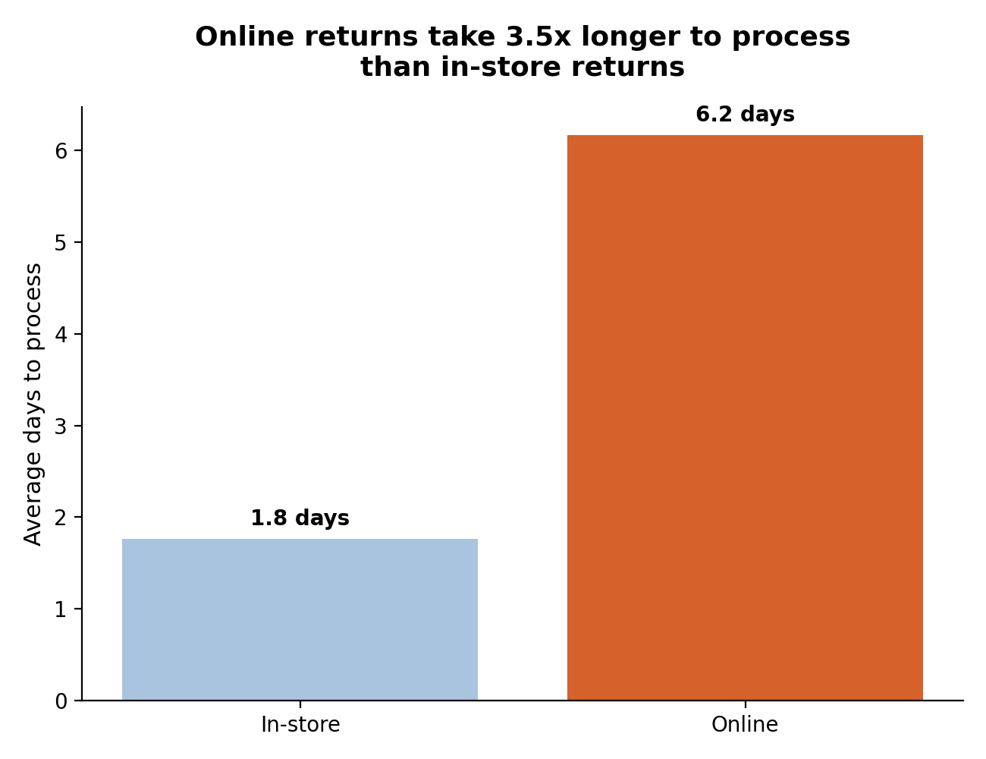
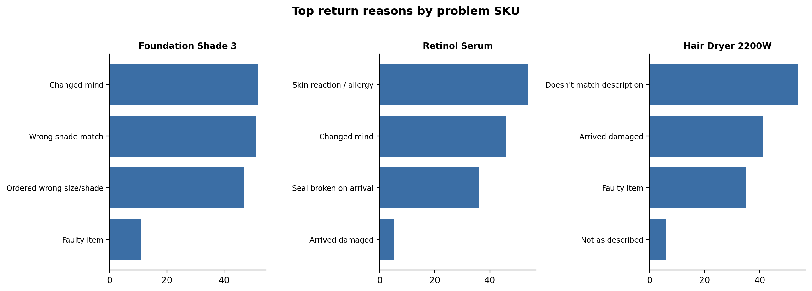
The three problem SKUs each fail for a different, fixable reason: a shade-matching issue (Foundation Shade 3), a skin-reaction/seal issue (Retinol Serum), and a damaged-in-transit/faulty pattern (Hair Dryer 2200W) — meaning three distinct, targeted fixes rather than one generic 'reduce returns' initiative.
4. Process: As-Is → To-Be
Mapping the current process exposes exactly where the visibility gap sits, and what the minimum viable fix looks like.
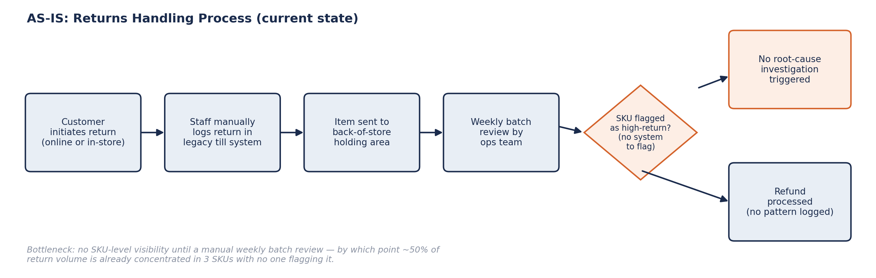
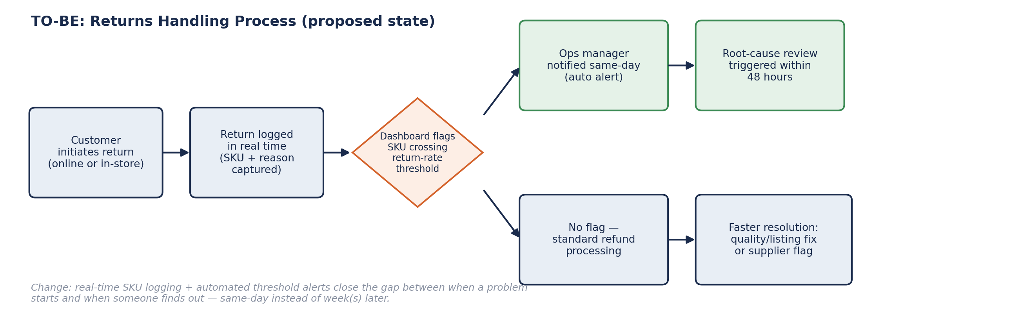
5. Requirements
Functional Requirements
- FR1 — Capture SKU and a standardized return-reason code at point of return, online and in-store.
- FR2 — Calculate a rolling 30-day return rate per SKU.
- FR3 — Alert the designated category owner when a SKU's return rate crosses a configurable threshold.
- FR4 — Auto-generate a weekly top-returns report (volume, reasons, refund value) for the buying team.
- FR5 — Track processing time from return logged to refund issued, segmented by channel.
Non-Functional Requirements
- NFR1 — Dashboard updates within 1 hour of new data being logged.
- NFR2 — Return-logging step usable by non-technical store staff with no extra training beyond a 1-page guide.
- NFR3 — Alerts integrate with existing email/Slack tooling — no new comms channel required.
- NFR4 — Reports exportable to Excel/PDF for offline stakeholder review.
6. User Stories & Acceptance Criteria
Written and tracked as a live backlog in Jira — summarized here.
US-1 As an Ops Manager, I want a real-time dashboard flagging SKUs that cross a return-rate threshold, so I can investigate root causes before losses accumulate.
Acceptance criteria: Dashboard updates within 1 hour of a logged return · threshold configurable per category · alert fires when a SKU crosses 15% return rate in a rolling 30-day window.
US-2 As a Store Associate, I want to log the SKU and return reason at the point of return, so head office has visibility into why items come back.
Acceptance criteria: Refund cannot be completed without SKU + reason code · reason codes standardized across online and in-store.
US-3 As a Customer Service Lead, I want online returns routed through a faster processing lane, so refund times match in-store expectations.
Acceptance criteria: Online returns tagged at intake · 3-day average processing SLA · weekly SLA compliance report auto-generated.
US-4 As a Buying/Merchandising Manager, I want a weekly automated report of top-return SKUs with reason breakdown, so I can flag supplier or listing issues early.
Acceptance criteria: Report generated every Monday 9am · includes top 10 SKUs, reason codes, refund value · sent to buying team distribution list.
US-5 As an Ops Manager, I want root-cause investigations triggered automatically within 48 hours of a threshold breach, so issues don't sit unaddressed for a week or more.
Acceptance criteria: Ticket auto-created and assigned to category owner on threshold breach · 48-hour first-response SLA tracked.
7. Stakeholder Map
Stakeholder | Role in this change
Store Ops team | Responsible — logs SKU + reason accurately at point of return
Ops Manager | Accountable — monitors dashboard, triggers investigations
Buying / Merchandising | Consulted — acts on SKU-specific findings (shade guides, supplier quality)
Customer Service | Responsible — processes refunds within the new SLA
Finance | Informed — reviews refund cost impact quarterly
IT / Engineering | Responsible — builds the dashboard and alerting logic

8. Tools Used
Jira (backlog & user stories) · Confluence (requirements documentation) · Excel (data analysis, formulas, pivot-style summary) · BPMN-style process mapping · Python/pandas (initial data exploration)

